# MODULE 04 Data Acquisition and Duplication

Lara Alofi

2110886

Y

Computer Hacking Forensic Investigator (CHFI)

Lab Session Identifiers

1. <https://labclient.labondemand.com/LabClient/aaca03af-396b-4571-8d55-07504b73042a>

Username on EC-Council System

1. 2110886@uj.edu.sa

Lab 01

Lab 02

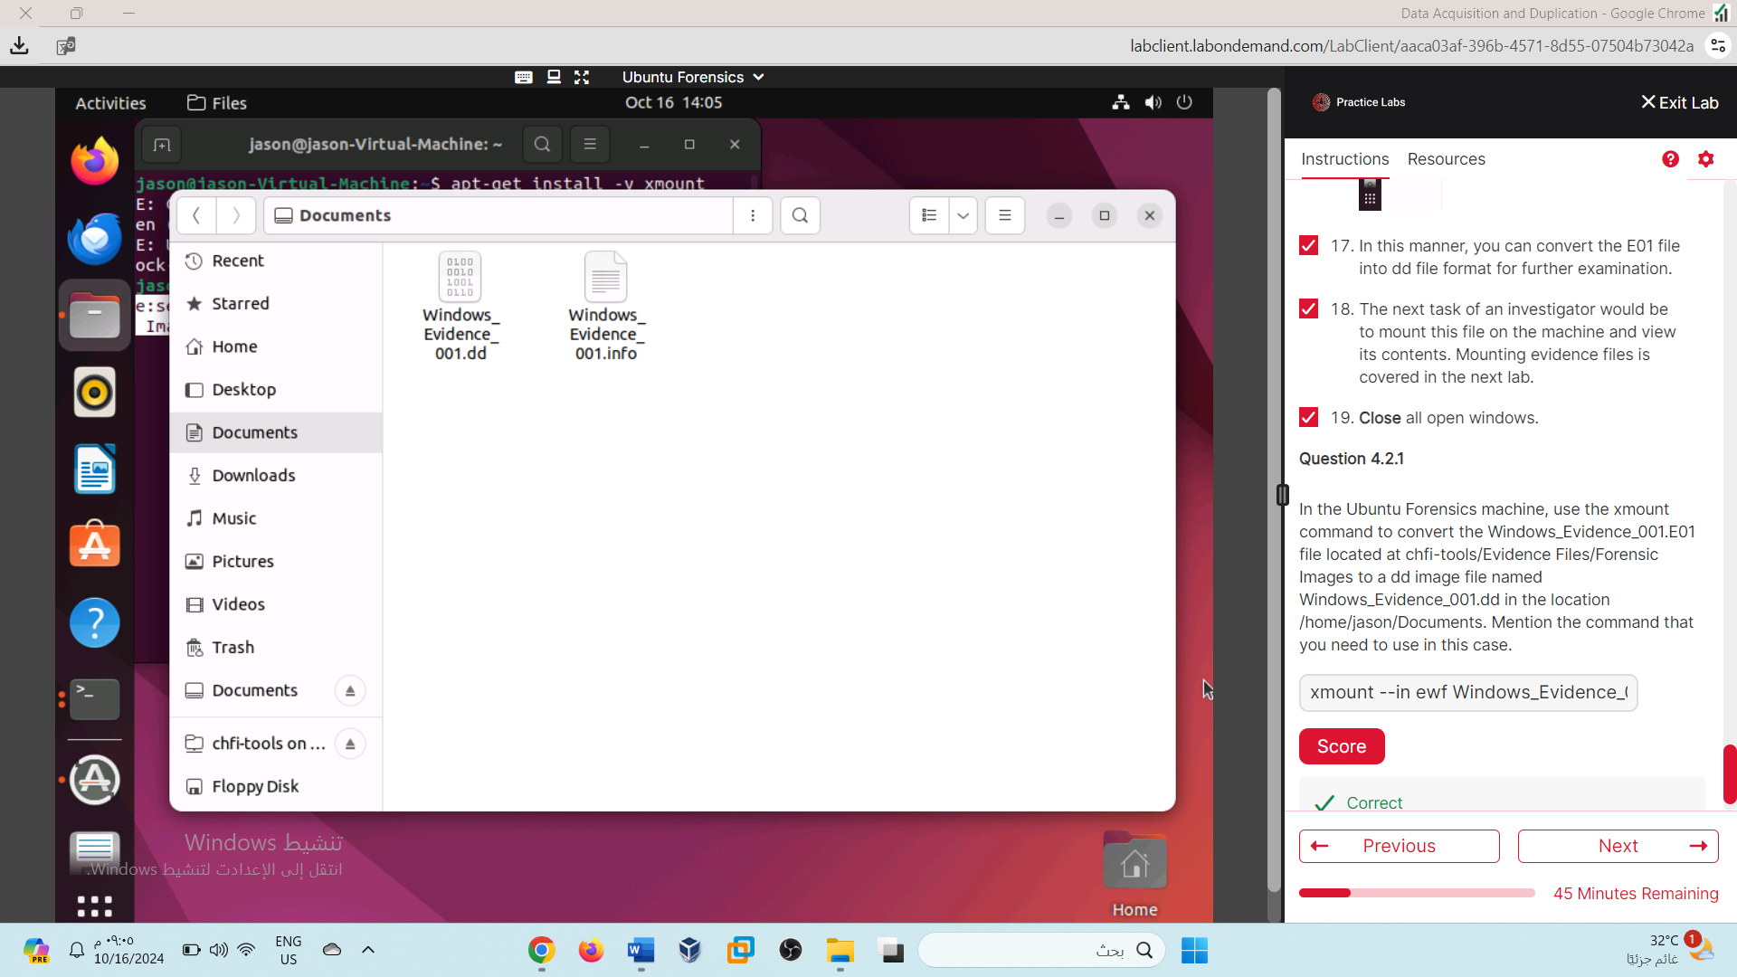

xmount --in ewf Windows_Evidence_001.E01 /home/jason/Documents

Lab 03

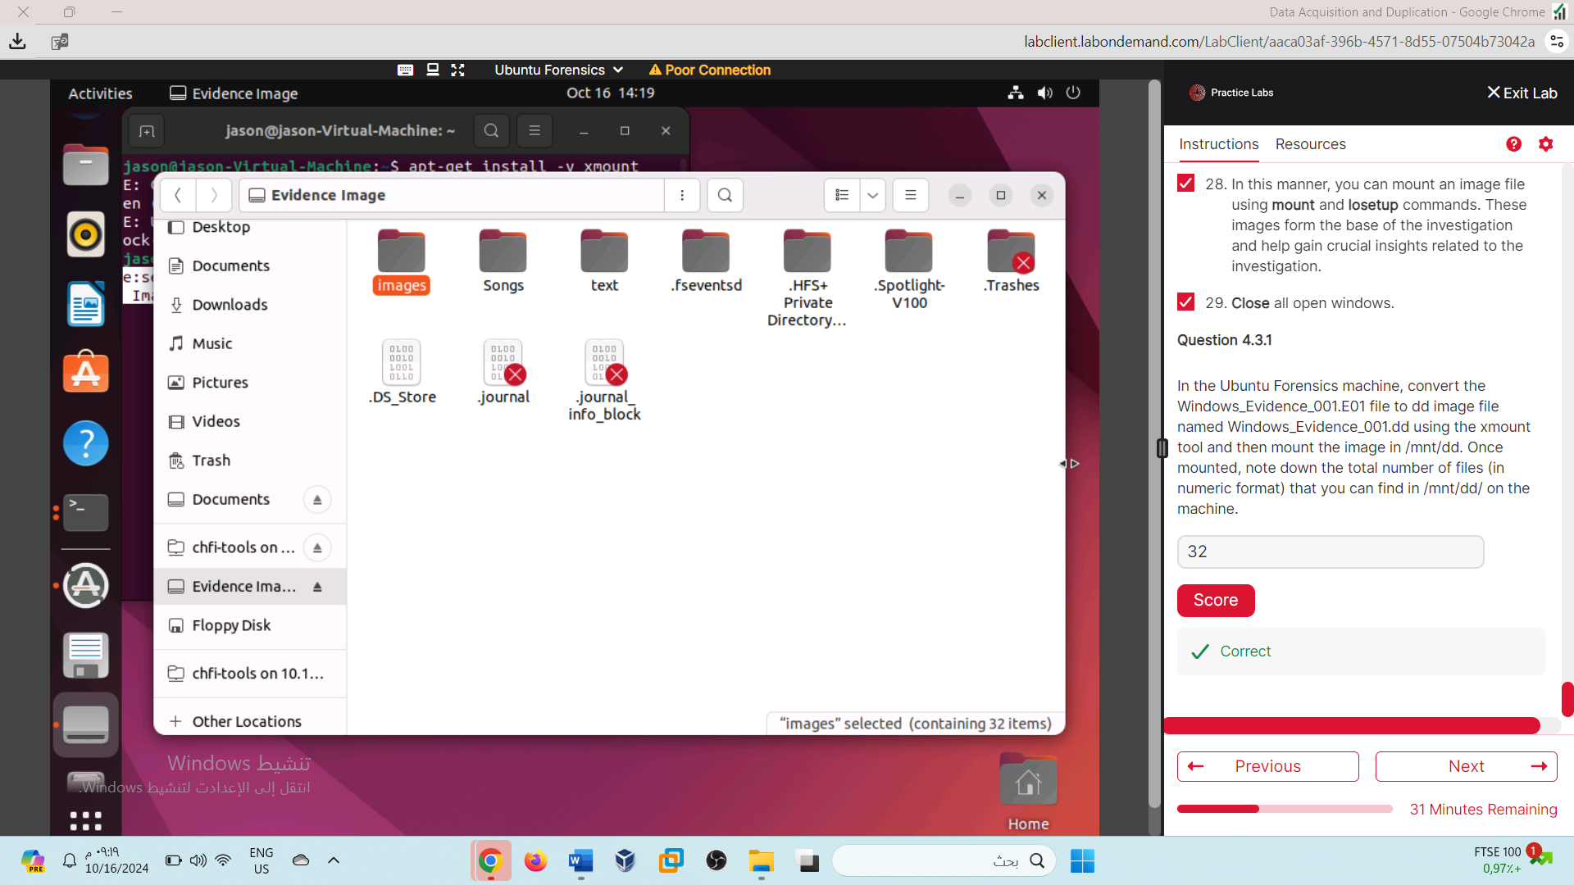

32

Lab 04

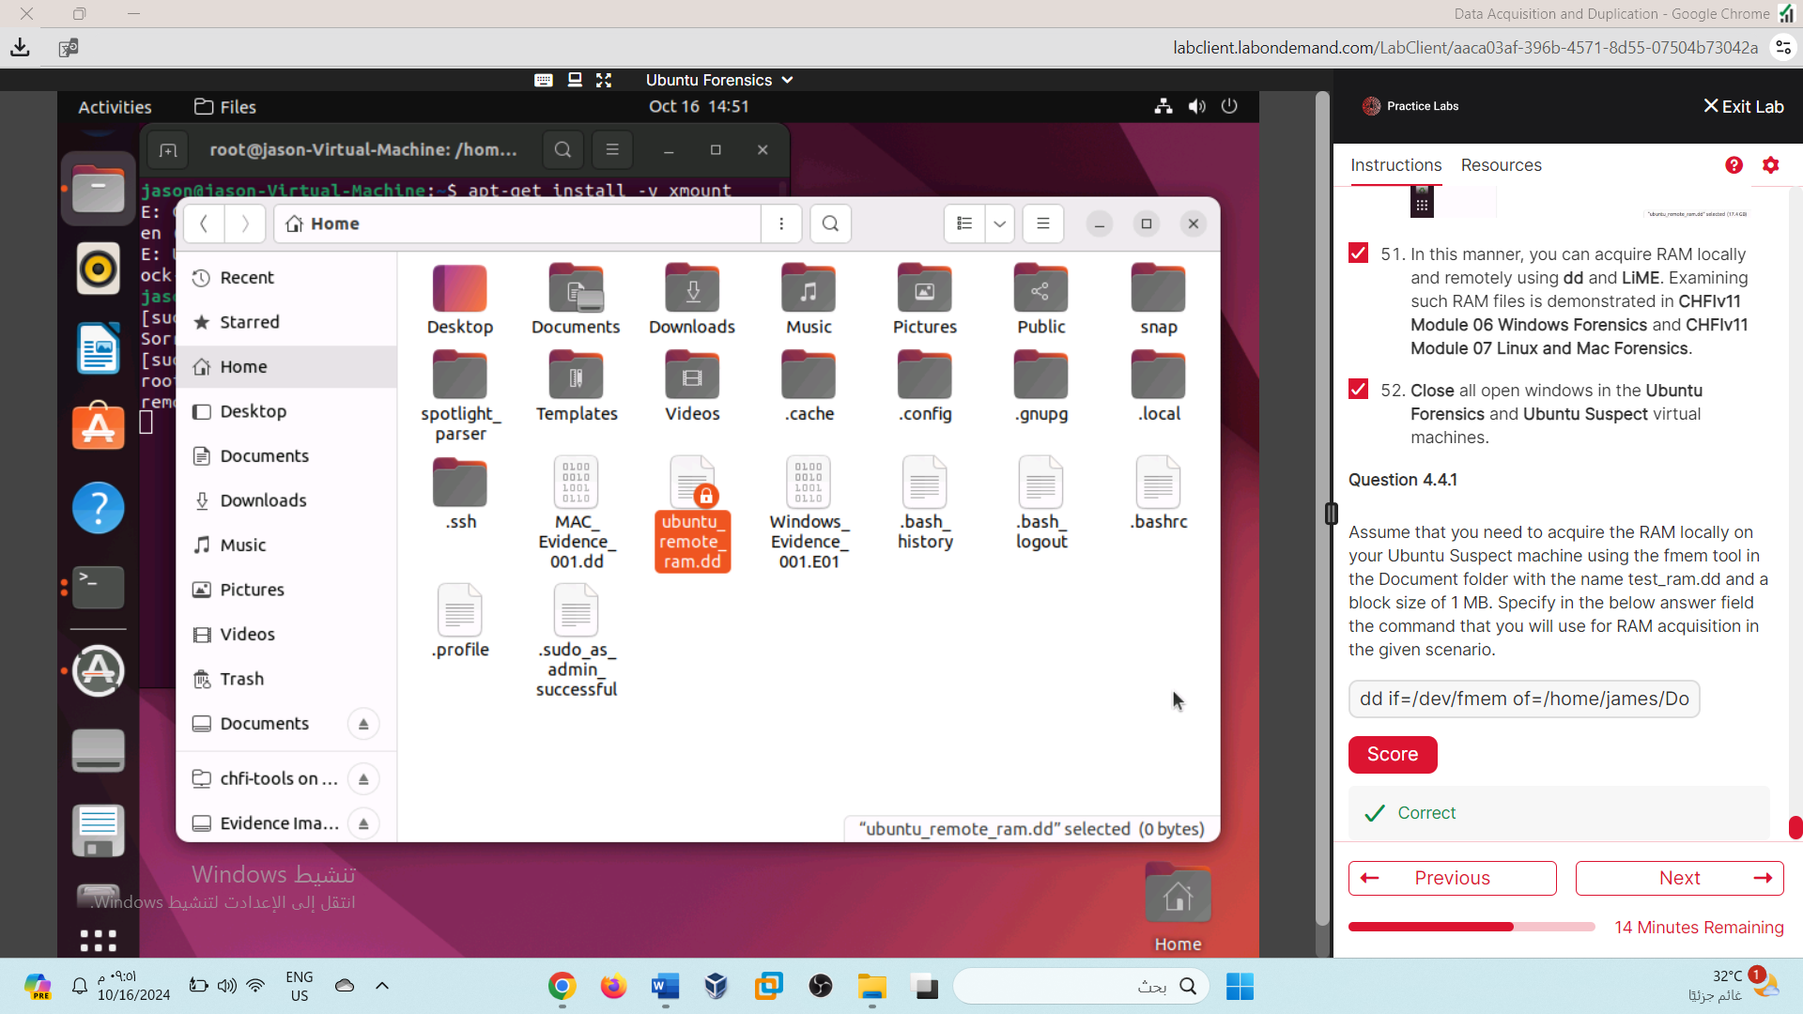

dd if=/dev/fmem of=/home/james/Documents/test_ram.dd bs=1MB

Lab 05

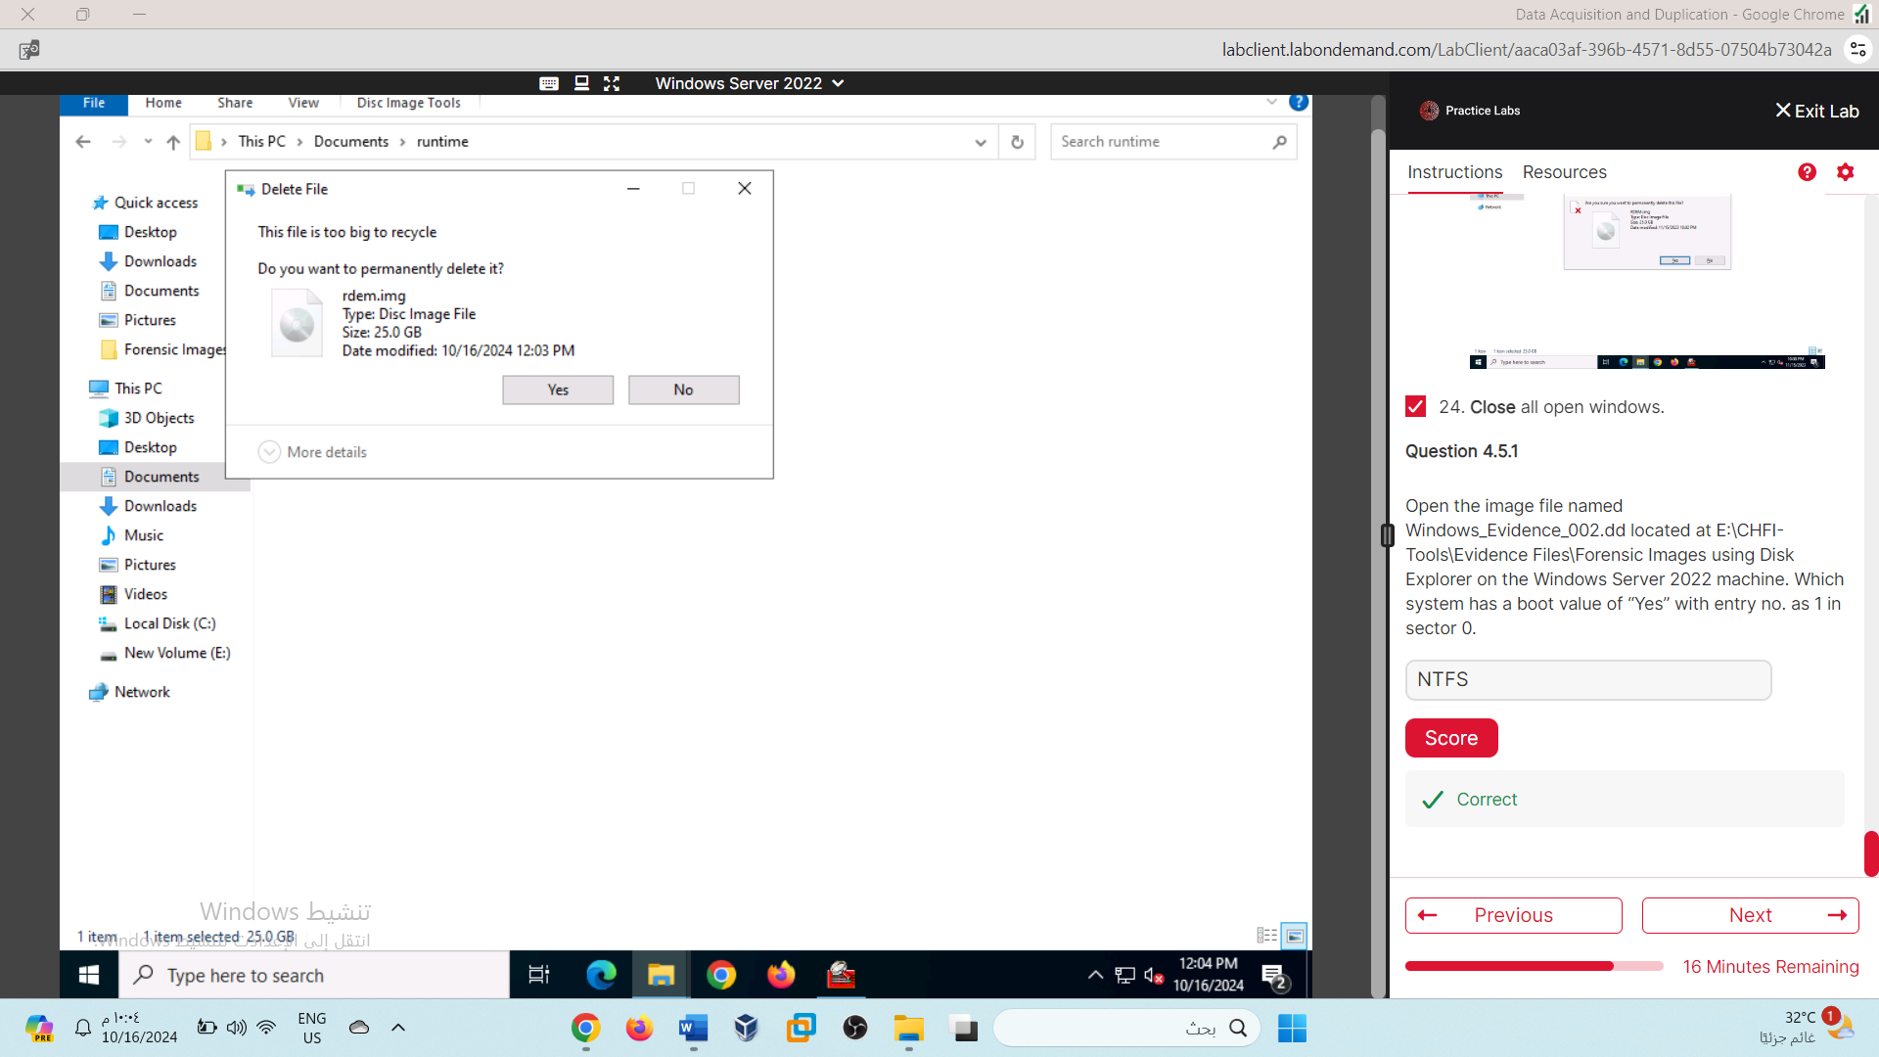

NTFS

Lab 06

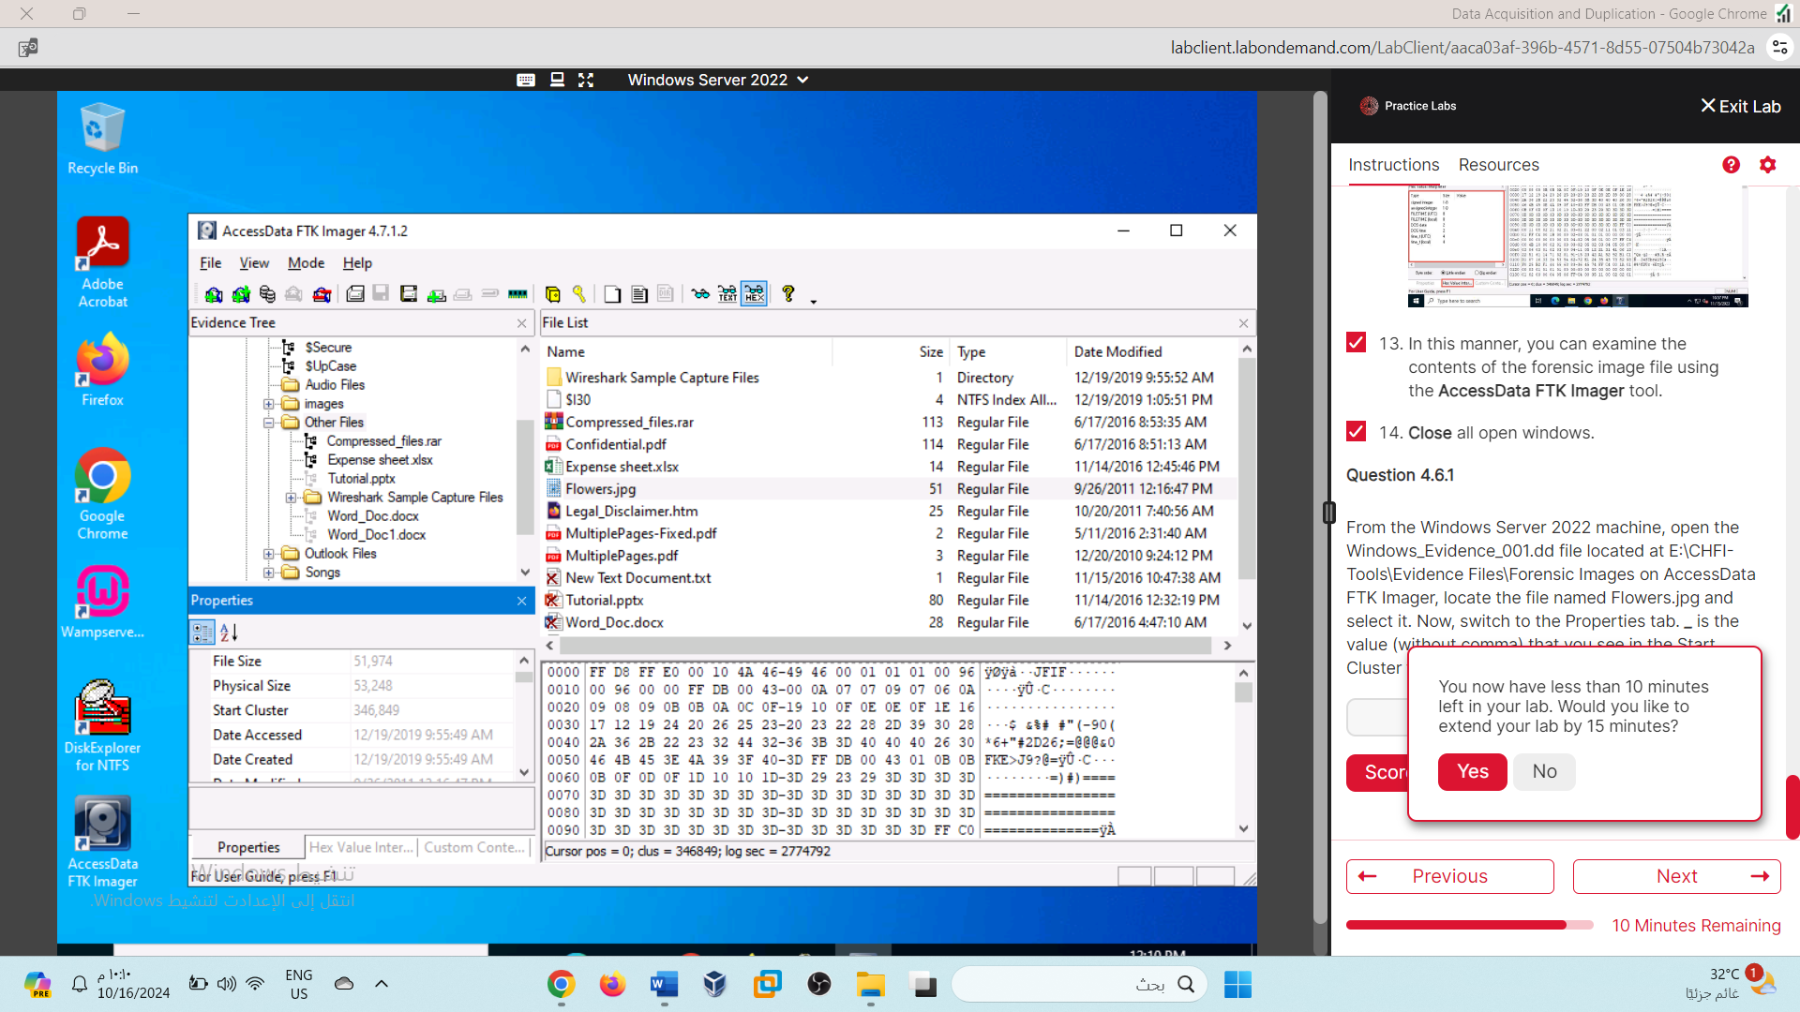

346849

Lab 07

